**Project Design Phase-I Solution Architecture**

|  |  |
| --- | --- |
| Date | 17 October 2022 |
| Team ID | PNT2022TMID38637 |
| Project Name | REAL TIME –RIVER WATER QUALITY MONITORING AND CONTROL SYSTEM |
| Maximum Marks | 4 Marks |

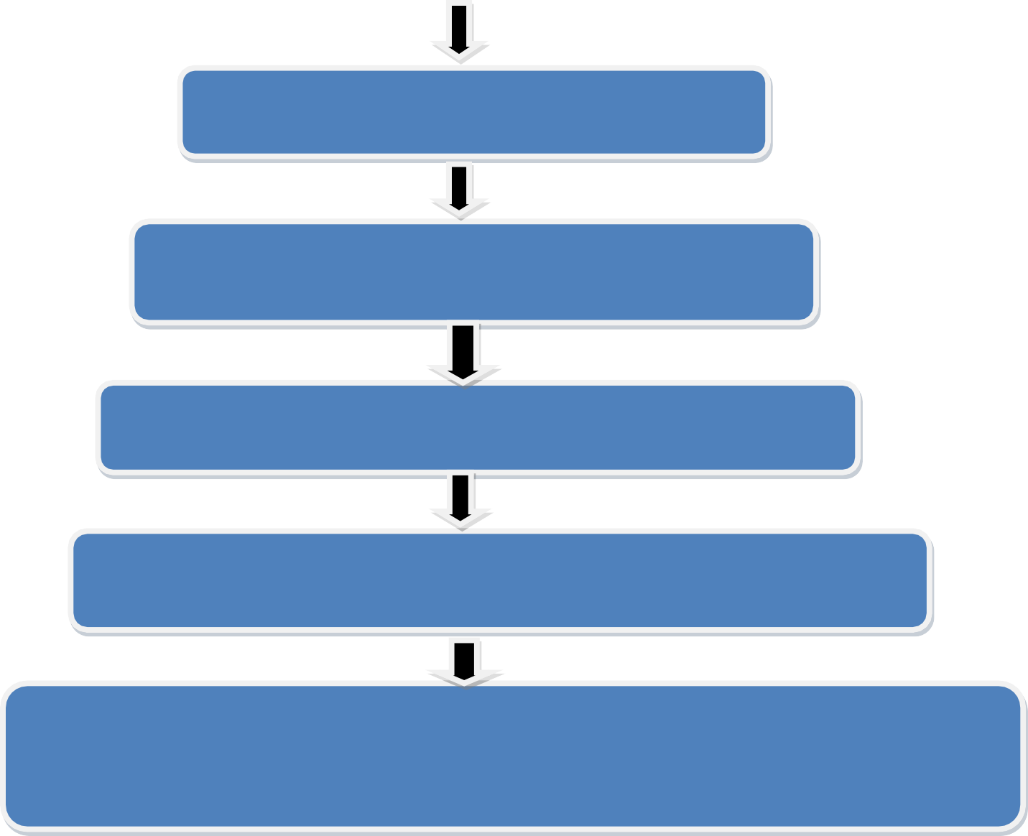

**Create an web application for monitoring and controlling the quality of river water**

It socially help water system managers identify threats to surface water earlier

Monitoring dust particles present in the water ,PH level and temperature using various sensor

Upgrade the traditional methods by using IOT system

Uses the real time data to track the quality to track the quality parameters

Altering the authorities, if the water quality is not good. So that they can announce the localities not to drink that water or live any living things